Spaceship Racer v0.1 - Game Mechanic Prototype
Copyright Shelagh Lewins 2010-2011
shelagh_lewins@hotmail.com
This version 27 February 2011

Overview

Game Concept
The long-term goal for Spaceship Racer is the Fastnet race in space.

Each player will guide their lightweight unmanned spaceship around a solar system, over a period of days or weeks. Match points will be awarded for successfully completing the course: championship points and trophies for winning. Skillful use of the ship’s systems, and attention to conditions, will bring victory.

Current prototype
This prototype is a game mechanic testbed for the propulsion systems – ion thruster and solar sail. If play-testers report positively on this prototype, I’ll develop it further, by adding more controls and things that can affect your progress. If not, I’ll start on something else!

In this testbed, a player guides their ship around a solar sail in a period of minutes. Use the solar sail and ion thruster to control your course. Solar activity will vary and solar flares may give you extra thrust or send you off course.

All units are made up, all forces are magnified and time greatly speeded up. The course is a 2D projection of a real solar system.

I would like to hear any feedback or suggestions, but please bear in mind that this is a minimal game mechanic prototype and I have deliberately not polished it up – there’s no point unless the game has potential.

There are just 3 levels in this first prototype. The first is really really simple and is just to let you get the hang of the controls. The third can be tricky. I’d love to hear your best time for each level.

IMPORTANT! “Start level” in the Settings dialog will let you start at whatever level you like.

Game screen

The Course
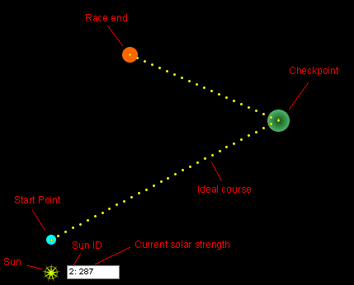
Your ship starts at the Start Point. The ship needs to travel to each checkpoint in turn and finally reach the Race End.

The Ideal Course marks the heading which would take an unpowered ship along the course under gravity alone. The Ideal Course is shown as straight lines on this projected map but would in reality comprise 3D curves through space.

Checkpoints represent regions near planetary bodies that will allow your ship to make a course alteration by gravitational slingshot. The more accurately you hit the checkpoint, the better the slingshot will be.

Spaceship and Markers
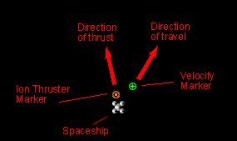
Velocity Marker – shows the current direction of travel.

Ion Thruster Marker – shows the direction in which the Ion Thruster will push the ship, when it is firing. The Ion Thruster may be set to any angle from 0 to 360 degrees.

Solar Sail
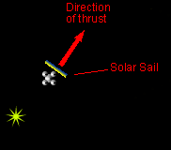
The solar sail is retracted by default, and you may deploy and retract it. It is always initially deployed perpendicular to the prevailing solar wind. You may adjust it up to 45 degrees clockwise or anticlockwise. This provides a steering effect but will reduce thrust. Adjusting the sail uses electricity.
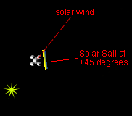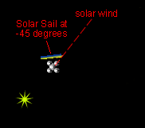

Suns
A sun’s activity level will vary according to solar cycles. Each sun has one or two solar cycles. When activity is high, flares are likely as indicated by the sun’s appearance. Flares increase solar wind strength greatly.

Sun icons indicate low to high activity, left to right.

Sun icons indicate ‘flare warning’ and ‘flare occuring’, left to right.

Click a sun to show or hide its current activity level. Solar wind strength falls off with distance from a sun according to an rsquared law.

Console
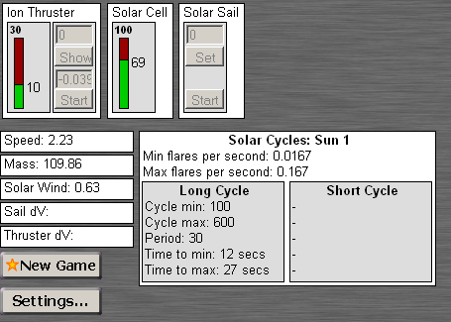

Various
Speed: spaceship speed
Mass: spaceship mass
Solar Wind: strength of solar wind experienced by spaceship.
Sail dV: acceleration caused by solar sail (when deployed).
Thruster dV: acceleration cause by ion thruster (when firing).

“New Game” will start a new game, beginning with the “Start level” selected in Settings.

“Settings” opens the Settings dialog.

Solar Cycles displays information about the currently selected sun (click on a sun to select it), including cycle periods in seconds and cycle durations.

Ion Thruster
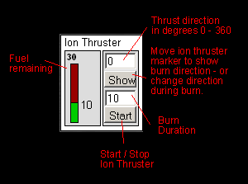
To fire the Ion Thruster, enter a burn duration in seconds and then select “Start”. The ion thruster will fire for the set amount of time, or until it runs out of fuel. You can stop the burn before the end if you want.

To choose the ion thruster burn direction, enter a new angle and select “Show”. You can set the ion thruster direction before starting a burn, and during a burn. Changing direction during a burn uses electricity.

Starting the Ion Thruster uses electricity. Fuel has mass so acceleration increases as fuel decreases. Solar Sail acceleration will also be greater when the ship is carrying less fuel.

Solar Cell
The Solar Cell provides electrical power for the Ion Thruster and Solar Sail. The ‘fuelgauge’ shows the amount of charge in the solar cell.

Solar Sail
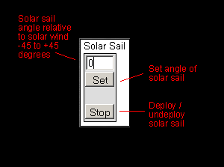
Deploying and retracting the solar sail uses electricity, as does changing the angle.

Settings Dialog
The Settings dialog contains some handy options (and one of no use at all).

- Set random seed – if checked, the Seed value will be used, ensuring that all random events happen the same each time you play.
- Start Level – choose which level you get when you select New Game.
- Radio Parameter 1 doesn’t do anything at all.

